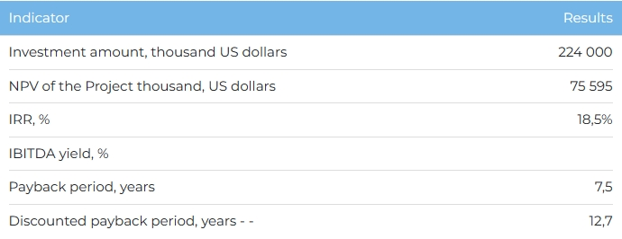
Products
The entire volume of electricity is planned to be sold on the domestic market. Upon reaching the design capacity, the annual volume of production and sale of electricity will be more than 2,000 million kWh.
Project
The project provides for the construction of a gas turbine power plant (GTPP) with a capacity of 280 MW in the Zhetygen rural district of the Ili district of the Almaty region. Current status of the Project:
- The concept of the Project has been developed and work is underway to develop a feasibility study;
- Received license No. 1902476 from the Ministry of National Economy for the purchase of electrical energy for the purpose of electricity supply dated 06/07/2019;
- There is a specification for designing and obtaining an AGDS gas pipeline branch with a capacity of 50 thousand m3 / hour for gas supply to a GTPP from the Baiserke-Kapshagay gas pipeline.
Company
Since 2017, Kaz Energo Trade LLP has been implementing projects in the energy sector, including the production and sale of electrical energy. The Company's staff has experience in designing, building and launching the Almaty-Kapshagay gas pipeline, 10/110/220 kV power lines with a length of more than 400 km, 38 110 and 220 kW substations, a gas liquefaction plant in Kapshagay, the Zhanazhol GTPP, etc.
Market
- The production of electrical energy in Kazakhstan is carried out by 207 power plants of various forms of ownership. As of 01/01/2023, the total installed capacity of power plants in Kazakhstan was 24,523.7 MW, and the available capacity was 20,761.7 MW.
- In 2023-2029 Electricity deficit is forecasted in Kazakhstan at the level of 1.22 billion kWh. By 2029, over 80% of electricity (115 billion kWh) will be provided by existing capacities, while about 26 billion kWh is planned to be provided through the construction of new power plants.
What is the attraction of the project?
- High demand. Almaty region is energy deficient, where electricity consumption exceeds its production by almost two times. In 2022, the deficit in the region amounted to about 4 billion kWh. In connection with the active development of the territory of the region. an increase in the load on the node along the route "Almaty-KonaevOskemen" and a shortage of electrical capacities of about 650-700 MW are expected. In addition, energy production is complicated by the fact that today about 56% of power plants have been in operation for more than 30 years, and physical wear and tear reaches 60%, which reduces the efficiency of plants by more than 2 times.
- Environmental friendliness. The use of coal as the main fuel for electricity generation in the country causes irreparable damage to the environment and climate. In this regard, the country is pursuing a consistent policy of replacing coal-fired power plants with gas-fired and RES-powered power plants.
- Increasing capacity and new markets. The availability of resources and the use of innovative technologies make it possible to increase production capacity and diversify the consumer base, as well as to produce thermal energy in the future.
Investment proposal
For the implementation of the Project, financing in the amount of 224,000 thousand US dollars (at the rate of 449.2 tenge) is required, including:
- 70% (USD 156,800 thousand) - debt financing (subject to collateral);
- 30% (USD 67,200 thousand) - investor participation.
The proposed financing structure and state support measures are indicative, the final financing structure and the stake in the Project will be determined based on the results of joint negotiations with the investor.

